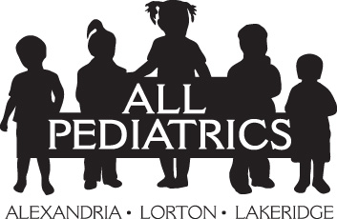

FOODS APPROPRIATE FOR BABIES
6-9 MONTHS OLD

Mashed bananas or small slices  Applesauce  Canned pears and peaches  Soft cooked/mashed vegetables  Iron fortified infant cereals  Chopped meat*  Cottage cheese* | Yogurt (whole milk)*  Cheerios (fruit/veggie puffs)  Toast  Graham Crackers  Arrowroot cookies  Zwieback toast  Plain rice cakes (wagon wheels)

*Meat and vegetables are now recommended as first foods as opposed to cereal. Dairy products are introduced more toward 7-8 months. Remember the infant is still getting plenty of protein from breast milk and/or formula.

*Introducing peanut foods early to your baby will help prevent peanut allergy

“Finger foods” are introduced once the infant has become a more proficient eater, about 8-9 months. Larger pieces of table foods like toast and rice cakes can be started earlier and often assist with positive oral reinforcement for the texture sensitive infant and help with teething.

NO HONEY UNTIL THE CHILD IS OVER 12 MONTHS OF AGE

