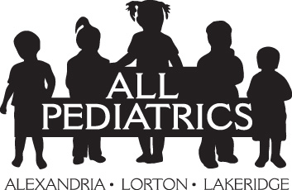 | FAMILY ACKNOWLEDGEMENT OF RECEIPT OF  NOTICE OF PRIVACY PRACTICES AND CONSENT TO TREATMENT  I acknowledge that I have been provided the ALL Pediatrics (“ALLPeds”) Notice of Privacy Practices (“Notice”):  - It tells me how ALLPeds will use my child’s health information for purposes of their treatment, payment for that treatment, and ALLPeds’ health care operations.  - The Notice explains in more detail how ALLPeds may use and share my child’s health information for other than treatment, payment, and health care operations.  - ALLPeds will also use and share my child’s health information as required/permitted by law.  - I consent to ALLPeds using and disclosing my child’s treatment records maintained by ALLPeds for the purposes detailed in ALLPeds’ Notice of Privacy Practices.  Patient’s Complete Legal Name:___________________________________ Patient’s DOB:________________  (please print)  Patient’s Complete Legal Name:___________________________________ Patient’s DOB:________________  (please print)  Patient’s Complete Legal Name:___________________________________ Patient’s DOB:________________  (please print)  Patient’s Complete Legal Name:___________________________________ Patient’s DOB:________________  (please print)
I give authorization to the person(s) listed below to discuss medical records, obtain medical advice and consent to medical treatment for the above referenced child(ren) with a provider of ALL Pediatrics or at any facility which the provider deems necessary. This person(s) has my permission for medical decision making. ALL Pediatrics staff will verify the ID of the person named below.

Signature:______________________________ Date:__________ Current email:______________________

(Parent/Legal Guardian or Representative*)

Relationship to Patient:__________________________________

*may be requested to show proof of representative status

File in patient’s chart HIPAA Document
Retain for minimum of 6 years

